

**University of Science and Technology Chittagong (USTC)**

Faculty of Science, Engineering & Technology

Department of Computer Science & Engineering

**Course code:** CSE 324

**Course Title:** Artificial Intelligence and Expert Systems Lab

**Project title:**

AI Smart Bin - Intelligent Waste Management Solution

By

**Team Elite**

**Submitted by:**

|  |  |
| --- | --- |
| **Name** | **ID** |
| Abhilash Chowdhury (L) | 22010110 |
| Tanmay Das | 22010105 |
| Tazrian Binte Mahfuz | 22010116 |
| Pritom Gupta | 22010134 |

Semester: 6th

Batch: 38th

Dept.: CSE, FSET

**Submitted to:**

Debabarata Mallick

[ Lecturer ]

CSE, FSET, USTC

**Problem Statement**

With increasing environmental concerns about waste management, improper segregation of waste into organic and inorganic types continues to be a critical issue. Traditional methods of waste classification rely on manual sorting, which is time-consuming and inefficient. The need for an automated solution to effectively classify waste at the disposal level is essential to improving recycling processes and waste treatment. This project addresses the challenge by developing a smart dustbin that uses sensor data and machine learning to automatically classify waste as organic or inorganic.

**Abstract**

The Smart Bin AI is designed to automate waste classification into organic and inorganic categories based on sensor input. The system utilizes an ultrasonic sensor to detect when waste is placed in the bin, a soil moisture sensor to determine moisture levels (indicating organic waste), and an infrared (IR) sensor for object detection. A machine learning model, specifically a RandomForestClassifier, is trained using moisture level data to classify waste in real time. The waste type and moisture information are logged into a CSV file for monitoring and analysis. The system includes real-time feedback mechanisms through a buzzer and LED indicators. The project presents a solution to improve waste segregation at the source, thereby promoting efficient waste management practices.

**Features**

**Automatic Waste Detection:** The system opens the dustbin door automatically when an object is detected within a certain range (via ultrasonic sensor).

**Waste Type Classification:** The AI model classifies the waste as organic or inorganic based on real-time moisture sensor data.

**Moisture-Level-Based Classification:** Moisture levels are read and used as the primary feature to distinguish organic (high moisture) from inorganic (low/no moisture) waste.

**Real-Time Data Logging:** Waste type predictions, along with moisture levels and status checks, are logged with timestamps into a CSV file for tracking and analysis.

**User Feedback Mechanism:** A buzzer sounds if moisture (organic waste) is detected, and an LED indicates dry waste.

**System Reset:** After waste is placed and classified, the system resets itself, ready to detect and classify new waste.

**Methodology/Architecture**

The Smart Bin AI is built using the following methodology -

**Hardware Components:**

**Ultrasonic Sensor:** Detects the proximity of waste within 30 cm of the dustbin.

**Servo Motor:** Opens the dustbin lid when waste is detected and closes it after waste is removed.

**Soil Moisture Sensor:** Measures the moisture content of the waste, serving as the primary feature for classification.

**IR Sensor:** Detects the presence of waste in the bin and signals when the object is removed.

**Buzzer and LED:** Provide real-time feedback based on the moisture level and waste classification.

**Software Components:**

**Machine Learning Model:** A RandomForestClassifier is trained with labeled moisture level data to classify waste into organic or inorganic categories.

**Arduino Communication:** Data is transmitted from the Arduino sensors to a Python script via a serial connection.

**Data Logging:** A CSV file stores waste type predictions, moisture levels, and timestamped records.

**Workflow:**

**Waste Detection:** The ultrasonic sensor detects an object and opens the dustbin using the servo motor.

**Moisture and IR Detection:** The soil moisture sensor reads the moisture content of the waste, while the IR sensor confirms the presence of waste in the bin.

**AI-Based Classification:** The RandomForestClassifier predicts the waste type based on the moisture level.

**Data Logging:** The system logs the predicted waste type, moisture level, and match status into a CSV file.

**System Reset:** After detecting waste removal, the system resets, closing the dustbin and preparing for the next detection.

**Implementation of Arduino Code**

* **Why we use Arduino Code in our Project?**

The Arduino code is essential for automating and controlling the smart bin ai by integrating sensors (ultrasonic, IR, and soil moisture) and actuators like the servo motor and buzzer. It enables the dustbin to detect objects, identify waste types (organic or inorganic), and operate the lid autonomously. The code processes real-time sensor inputs, making decisions like opening the lid when waste is detected and closing it once the object is removed. It also communicates with a PC to send waste data for further analysis. Overall, the Arduino code makes the dustbin efficient, user-friendly, and capable of functioning without manual intervention.

* **How it works?**

**STEP 1: Object Detection (Ultrasonic Sensor)**

The ultrasonic sensor measures the distance to objects in front of the dustbin. If an object is detected within 30 cm, the system considers that something is approaching the bin.

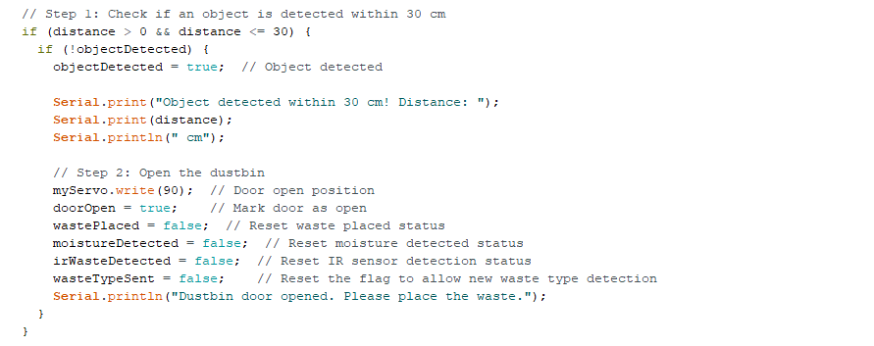

**Step 2: Opening the Dustbin (Servo Motor)**

Once the ultrasonic sensor detects an object, the servo motor moves the dustbin door to the open position (90°). This allows the user to place waste into the bin.



**Step 3: Waste Detection (IR Sensor and Soil Moisture Sensor)**

After the door is open, the IR sensor monitors for waste. Once waste is placed, it checks for the presence of moisture using the soil moisture sensor. If moisture is detected, the system assumes the waste is organic.



**Step 4: Moisture Detection and Buzzer/LED Alerts**

If moisture is detected, the system classifies the waste as organic, turns on the buzzer, and logs the moisture level. If no moisture is found, the waste is considered dry (inorganic), and the LED is turned on to indicate dry waste.

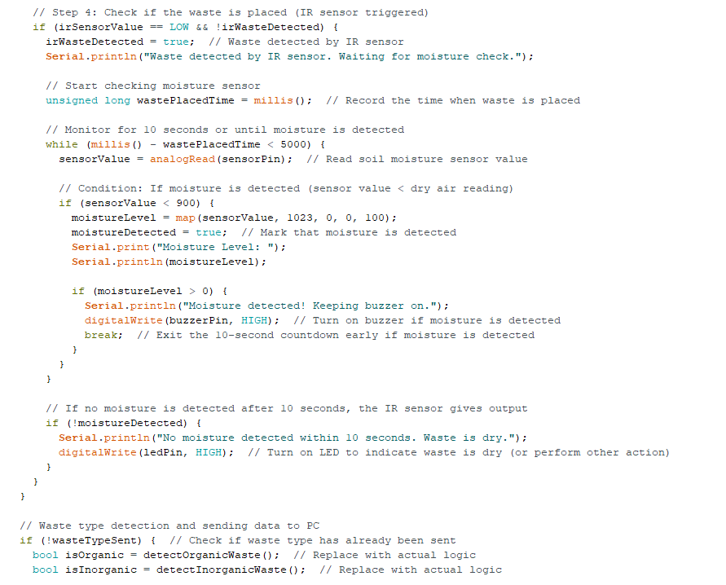

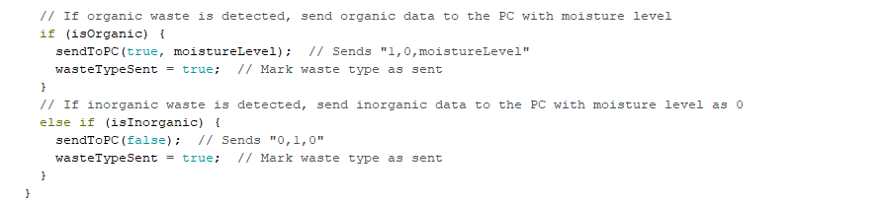

**Step 5: Waste Removal Detection (IR and Soil Moisture Sensor)**

After the waste is placed, the system continuously monitors both the IR and soil moisture sensors. If the waste is removed from the bin (IR sensor is high, and moisture sensor detects no moisture), the system resets the states.

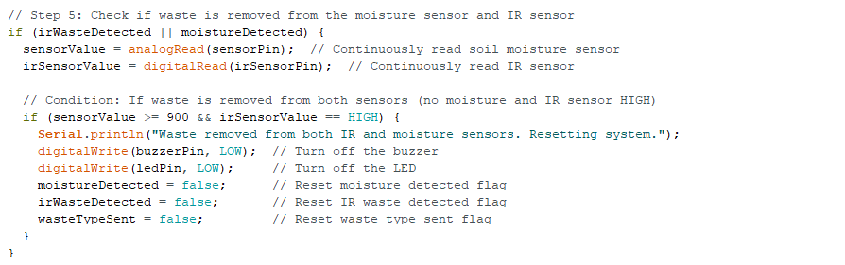

**Step 6: Object Removal from Detection Range**

After placing the waste, if the object (e.g., user's hand) is removed from the detection range of the ultrasonic sensor, a 10-second countdown begins to close the dustbin.

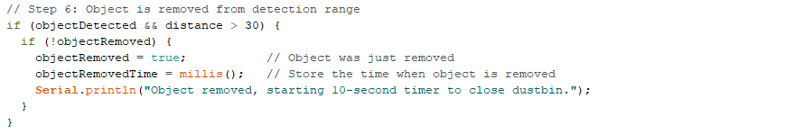

**Step 7: Closing the Dustbin (Servo Motor)**

After 10 seconds without any new objects being detected, the servo motor moves the door to the closed position (0°), sealing the bin. If a new object is detected within this time, the countdown resets to keep the door open.

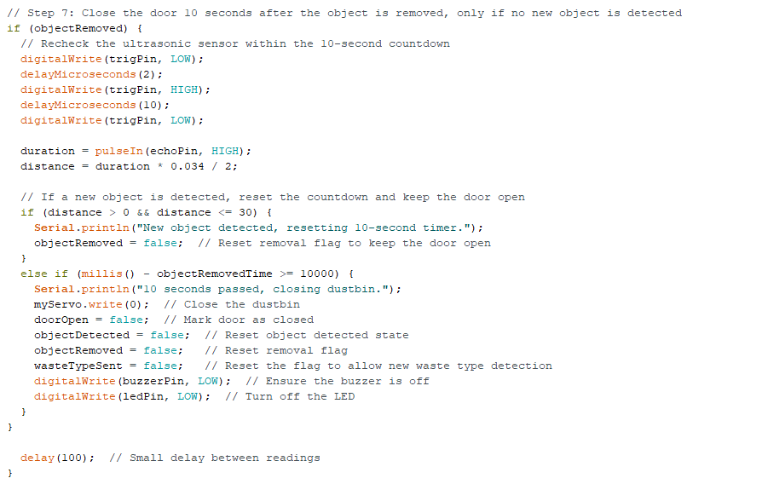

**Implementation of Random Forest**

* **Why we use Random Forest in our Project?**
* Random Forest is an ensemble machine learning algorithm that builds multiple decision trees during training.
* Each decision tree makes a prediction, and the majority vote (or average in regression tasks) across all trees is taken as the final output.
* For our project, the input is the moisture level of the waste, and the output is whether the waste is classified as organic or inorganic.
* **How it works?**

**Training the Model:**

* We have training data consisting of moisture levels and corresponding waste types. These values are used to train the model.
* The moisture levels (X_train) are the input features, and the waste types (y_train) are the target labels.
* A Random Forest Classifier is trained on this data to predict the waste type based on new moisture levels.

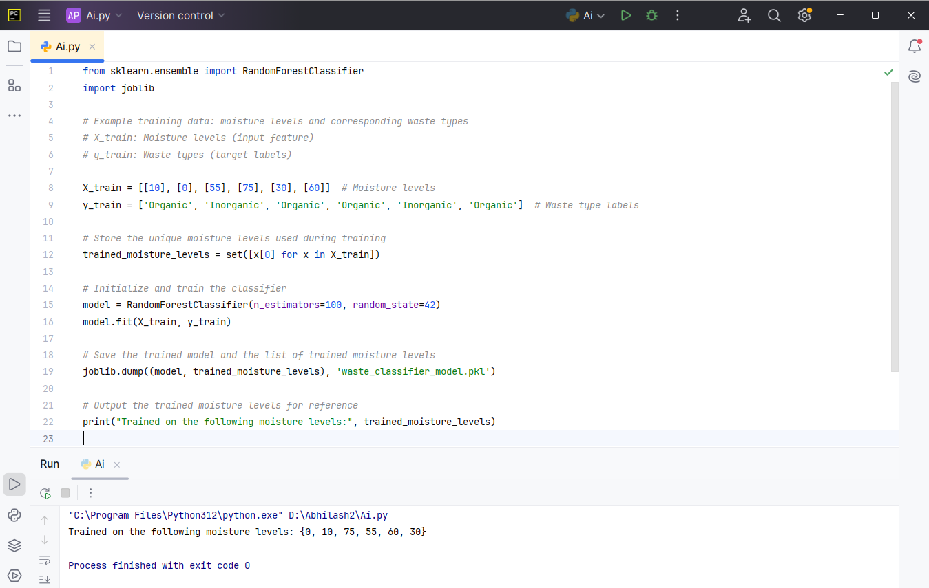

**Saving the Model:**

* After training, the model is saved using joblib so that it can be loaded and used later to classify new moisture levels in real-time as the Arduino provides them.

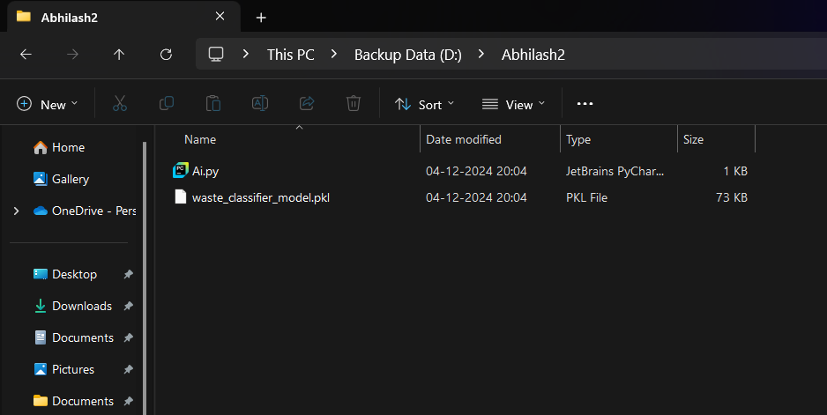

**Implementation of Machine Learning**

* **Why we use ML in our Project?**

We use Machine Learning (ML) in our smart dustbin project to enhance the efficiency and accuracy of waste classification. By leveraging ML, the system can analyze data from various sensors, such as the soil moisture sensor and IR sensor, to identify patterns and classify waste more intelligently. An ML model can learn to distinguish between organic and inorganic waste based on sensor readings and other inputs, improving detection accuracy.

The implementation of ML allows the dustbin to adapt and make more informed decisions, enabling continuous improvement in waste identification. This helps in better sorting of materials, leading to more effective waste management, reduced environmental impact, and optimized recycling processes. By utilizing ML, our project moves toward a more advanced and responsive waste management system.

* **How it works?**

**Data Preprocessing:**

* The Arduino sends data in the format moisture_level.
* This data is read via the serial connection and split into individual components.



* For our ML model, the primary input is likely the moisture_level, which the model will use to predict whether the waste is organic or inorganic.

**Using the Pre-trained ML Model:**

* You have loaded a pre-trained model (waste_classifier_model.pkl) using joblib.load. This model takes moisture levels as input and predicts the waste type (organic or inorganic).



* We will pass the moisture level to the model and let it predict the waste type.

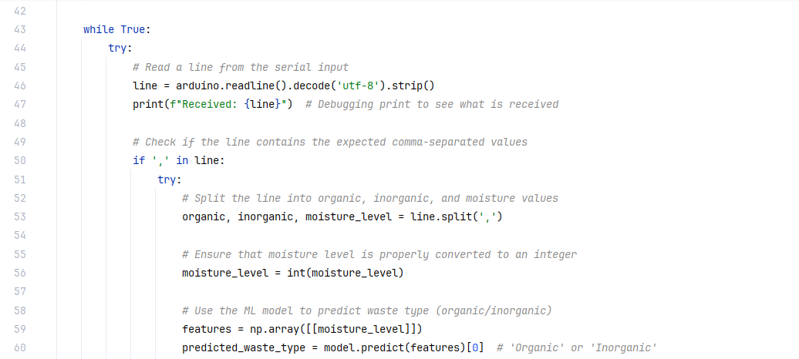

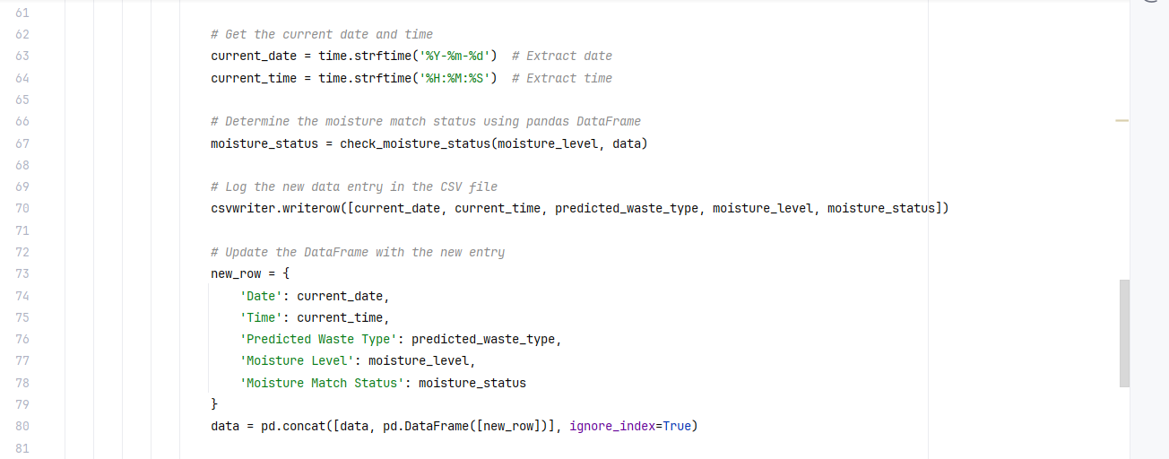

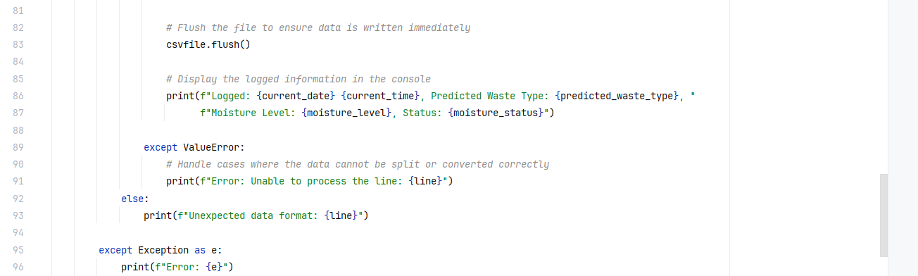

**Logging Data:**

* After predicting the waste type using the model, the predicted type, along with the moisture level, will be logged into a CSV file.

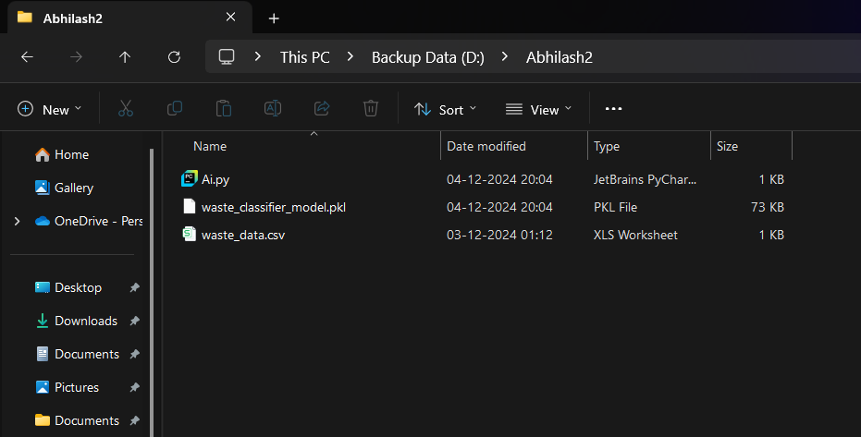

* The system also checks if the current moisture level matches any previously recorded levels (to track if the same waste type has been classified before).

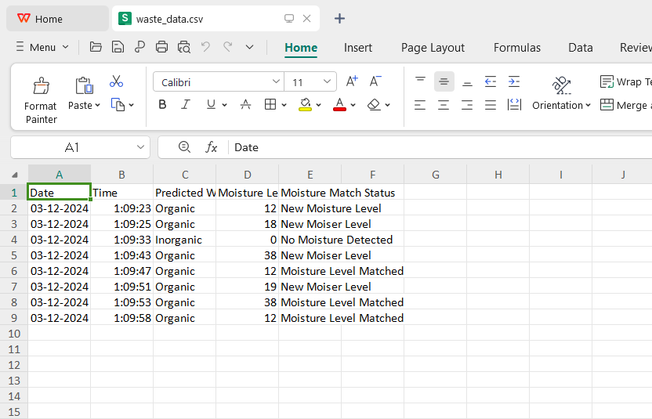

**Summary**

The Smart Bin AI successfully integrates machine learning with embedded sensors to automate waste classification at the point of disposal. The system uses real-time sensor data, particularly moisture levels, to distinguish between organic and inorganic waste, with feedback provided to the user via buzzer and LED indicators. By logging data into a CSV file, the system allows for performance tracking and data analysis. The project demonstrates an effective approach to improving waste segregation, contributing to more efficient waste management and recycling process.

**References**

1. Smart Dustbin by using Arduino and ultrasonic sensor (Youtube) -<https://www.youtube.com/watch?v=9yrP1CZN3Ds>
2. How to make Wet Dry Metal waste segregation project || Smart dustbin project using Arduino (Youtube) - <https://youtu.be/4XedfXtPxLQ?si=2F1v6EaSIa1xGRud>
3. Smart Bin (Arduino project Hub) –

<https://projecthub.arduino.cc/mohammadsohail0008/how-to-make-smart-dustbin-for-your-home-2fd84f>

1. Ultrasonic Sensor (Last Minute Engineers) –

<https://lastminuteengineers.com/arduino-sr04-ultrasonic-sensor-tutorial/>

1. Soil Moisture Sensor (Circuit Digest) -

[https://circuitdigest.com/microcontroller-projects/interfacing-soil-moisture-](https://circuitdigest.com/microcontroller-projects/interfacing-soil-moisture-sensor-with-arduino-uno)

[sensor-with-arduino-uno](https://circuitdigest.com/microcontroller-projects/interfacing-soil-moisture-sensor-with-arduino-uno)

1. IR Sensor (Circuit Digest) -

[https://circuitdigest.com/microcontroller-projects/interfacing-ir-sensor-module -](https://circuitdigest.com/microcontroller-projects/interfacing-ir-sensor-module -with-arduino)

[with-arduino](https://circuitdigest.com/microcontroller-projects/interfacing-ir-sensor-module -with-arduino)

1. Servo Motor (Last Minute Engineers) -

<https://lastminuteengineers.com/servo-motor-arduino-tutorial/>

1. “A Brief Study on Random Forest Using Python” Madhav, Shubham Kohli, Himanshu Rawat, Priyanshu Joshi (Department of Information Technology), Dr. Akhilesh Das Gupta (Institute of Technology and Management, New Delhi) - [https://ijaem.net/issue_dcp/A%20Brief%20Study%20on%20Random%20Forest%20Using%20Python.pdf](https://ijaem.net/issue_dcp/A%20Brief%20Study%20on%20Random%20Forest%20Using%20Python.pdf%20)

* GitHub Link - <https://github.com/T-a-n-m-a-y-D-a-s-TD/Project--AI-SmartBin_2024>